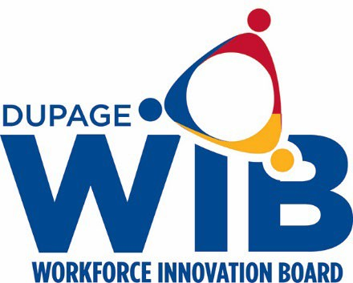

DuPage Workforce Innovation Board Meeting Dates 2026

The DuPage Workforce Innovation Board meets the fourth Wednesday of every other month from 7:30 a.m. – 9:00 a.m. at the workNet DuPage Career Center located at:
2525 Cabot Drive
Suite 302
Lisle, IL 60532

Full Board Meetings Executive Committee

Wednesday, January 28, 2026 Wednesday, February 25, 2026

Wednesday, March 25, 2026 Wednesday, April 22, 2026

Wednesday, May 27, 2026 Wednesday, July 22, 2026

Wednesday, June 24, 2026 Wednesday, September 23, 2026

Wednesday, August 26, 2026 Wednesday, November 18, 2026

Wednesday, October 28, 2026 *November is the 3rd week due to Thanksgiving.

