-

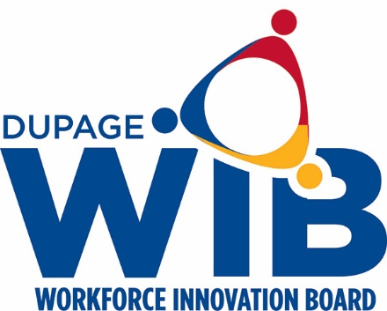

DuPage Workforce Innovation Board Meeting
Wednesday, August 26, 2020
7:30am-9:30am
2525 Cabot Drive, Suite 302
Lisle, IL 60532

Roll Call/Establish Quorum
Chair Tiffany Rotondo presided over the meeting. The meeting was called to order at 7:33am. Roll call was taken, and a membership quorum was present.

Members Present
Dan Allen | Ian Hardie
Kevin Bass | Tamryn Hennessy
Penny Clancy | TJ Jarman
Jane Clark | Mary Keating
Dan Deasy | Marilyn Liwanag
Michelle Einfelt | Tiffany Rotondo
Jeff Feucht | Darlene Ruscitti
Jim Gamache | Barry Saltzman
Debbie Gaspari | Barb Szczepaniak
Calvin Giles | Bernie Szczepanski
Beatris Gonzalez | Christine Torres
Kate Wollensak | Tom Wendorf

Members Absent
Greg Bedalov | Jeffrey Feucht
Joe Cassidy | Patty Ryan Vincent
Laura Crawford | Mike Kish

Others Present
Jamie Brown
Lisa Schvach
David Sabathne

Public Comment
- There was no public comment.

Review of June 24, 2020 minutes
- Motion by Tom Wendorf
- Second by Marilyn Liwanag
- All ayes via roll call vote
- Motion APPROVED

Fiscal Report
Lisa presented the fiscal report. This report reflects the remaining expenditures from the PY19 grant. All required benchmarks set by DECO were met. Additional grants include the Trade Grant, CSBG, Tollway Grant, IE COVID grant money for small businesses and the Disaster Recovery grant.

OSO Report
Dave presented the One Stop Operator report. He explained the numbers were lower in June due to the fact that the application was posted on the website. Dave also noted that traffic to the center has remained constant, there has not been a spike in inquires to the Center.

Warn Report
Jamie presented the WARN report. There has not been much change to the report in the last few months. Two of the local hotels have gone from furlough to permanent layoff, the Rapid Response Liaison is working to connect with the HR departments. It evident that this report is not reflective of all the layoffs. Lisa is working with DECO to address this issue and provide the local areas with assistance in reaching companies.

workNet DuPage Update
Lisa shared a presentation including unemployment statistics, local DuPage County unemployment rates by city, review of PY20 allocation and additional grants, and the Center’s response to COVID.

Supportive Service Policy Update
The policy has an added provision of laptop loan services. The Center has procured laptops to loan if a participant does not have access to the appropriate technology to attend an online training program.
- Motion to approve by Mary Keating
- Second by Kate Wollensak
- All ayes via roll call vote
- Motion APPROVED

The meeting was adjourned at 8:57am

