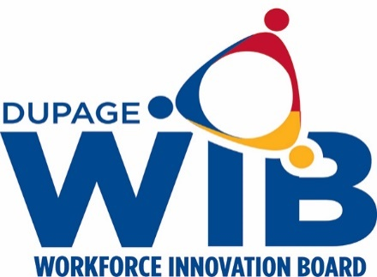

DuPage Workforce Innovation Board Meeting Dates 2021

The DuPage Workforce Innovation Board meets the fourth Wednesday of every other month from 7:30 a.m. – 9:30 a.m. at the workNet DuPage Career Center conference room located at:
2525 Cabot Drive
Suite 302
Lisle, IL 60532

Full Board Meetings Executive Committee Meetings

Wednesday, January 27, 2021 Wednesday, February 24, 2021

Wednesday, March 24, 2021 Wednesday, April 28, 2021

Wednesday, May 26, 2021 Wednesday, July 28, 2021

Wednesday, June 23, 2021 Wednesday, September 22, 2021

Wednesday, August 25, 2021 Wednesday, November 17, 2021
(second Wednesday-Thanksgiving)
Wednesday, October 27, 2021

