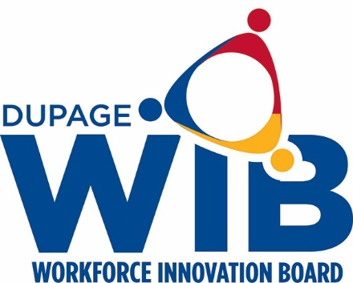

DuPage Workforce Innovation Board Slate of Officers 2021

Chair- Kate Wollensak
Vice-Chair- Jane Clark
Secretary- Ian Hardie
Treasurer- Joe Cassidy

