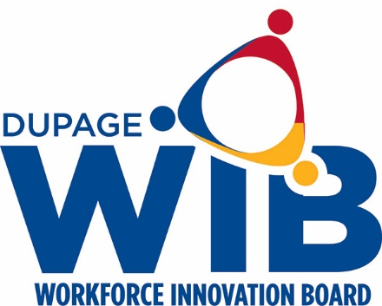

DuPage Workforce Innovation Board Meeting Minutes
January 26, 2022
7:30am-9:00am
Virtual Meeting

Call to Order/Roll Call
- Chair Kate Wollensak presided over the meeting. The meeting was called to order at 7:33 and a membership quorum was present.

Members Present
Dan Allen | Jane Clark | Calvin Giles | Jeff Feucht
Kevin Bass | Marianne Considine | Beatris Gonzalez | Nisha Patel
Joseph Cassidy | Dan Deasy | Tamryn Hennessy | Christine Torres
Patrick Chandler | Michelle Einfelt | TJ Jarman | Tom Wendorf
Roseanne Potter | Marilyn Liwanag | Mary Keating | Kate Wollensak

Members Absent
Greg Bedalov | Darlene Ruscitti
Laura Crawford | Barb Szczepaniak
Tiffany Rotondo

Others Present
Jamie Brown
Lisa Schvach
Miriam Jones
Joh

Public Comment
- There was no public comment

New Member Introductions
Jamie introduced two new members. Marianne Considine, Talent Acquisition Manager for Northwestern Medicine and Rosanne Potter, Human Resources Manager for Sentinel Technologies.

Approval of the August 25, 2021 minutes
- Motion to approve by Mary Keating
- Second by Dan Allen
- All ayes via roll call, motion APPROVED

Training Provider Renewals
Several programs currently on the approved provider list are set to expire. These programs require renewal, they meet the criteria to remain on the approved provider list.
- Motion to approve by Tiffany Rotondo
- Second by Marilyn Liwanag
- Abstentions by Joe Cassidy and Dan Deasy
- All ayes, via roll call vote, motion APPROVED

One-Stop Operator Report
Miriam Jones presented the One-Stop Operator report. She has included data from June and July so that trends can be identified. Traffic in the Center remains the same, however there is a slight increase in individuals who prefer to receive in-person services.

WARN Report
Jamie presented the WARN report. Overall WARN activity has been slow, which is usually the case in the summer months. Jamie provided an update on pre-layoff workshops that were conducted for affected workers.

Fiscal Report
Member Cassidy presented the fiscal report. The grant is nearly spent down and the County is awaiting the release of the PY21 funds.

workNet DuPage Report
Lisa Schvach presented an update on the Center. She reviewed current unemployment numbers, Center traffic and Center initiatives.

Adjournment

- Motion to adjourn by Barry Saltzman
- Second by Laura Crawford
- All ayes via roll call vote, meeting adjourned

